Assignment-1

**Submitted by: Tanmay Vig**

**Roll Number: 19BCS061**

**Batch: 2nd year CSE**

**Exercise 1:** Create the tables described below.

1. Table Name: Client_Master

Description: used to store information about clients.

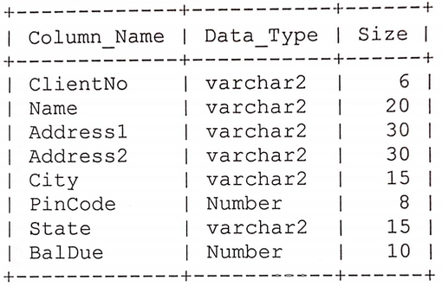

1. Table Name: Product_Master

Description: Used to store information about products.

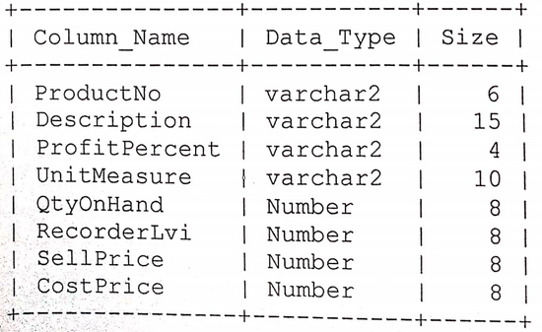

1. Table Name: Salesman_Master

Description: Used to store information about salesman working in the company.

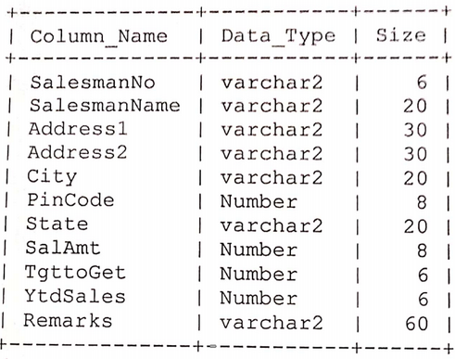

**Answer:**

1. **Command:**

CREATE TABLE Client_Master(

-> ClientNo VARCHAR(6),

-> Name VARCHAR(20),

-> Address1 VARCHAR(30),

-> Address2 VARCHAR(30),

-> City VARCHAR(15),

-> PinCode INT(8),

-> Sate VARCHAR(15),

-> BalDue INT(10));

**Output:**

Query OK, 0 rows affected, 2 warnings (0.09 sec)

**Command:**

DESC Client_Master;

**Output:**

+----------+-------------+------+-----+---------+-------+

| Field | Type | Null | Key | Default | Extra |

+----------+-------------+------+-----+---------+-------+

| ClientNo | varchar(6) | YES | | NULL | |

| Name | varchar(20) | YES | | NULL | |

| Address1 | varchar(30) | YES | | NULL | |

| Address2 | varchar(30) | YES | | NULL | |

| City | varchar(15) | YES | | NULL | |

| PinCode | int | YES | | NULL | |

| Sate | varchar(15) | YES | | NULL | |

| BalDue | int | YES | | NULL | |

+----------+-------------+------+-----+---------+-------+

1. **Command:**

CREATE TABLE Product_Master(

-> ProductNo VARCHAR(6),

-> Description VARCHAR(15),

-> ProfitPercent VARCHAR(4),

-> UnitMeasure VARCHAR(10),

-> QtyOnHand INT,

-> RecorderLvi INT,

-> SellPrice INT,

-> CostPrice INT);

**Output:**

Query OK, 0 rows affected (0.04 sec)

**Command:**

DESC Product_Master;

**Output:**

+---------------+-------------+------+-----+---------+-------+

| Field | Type | Null | Key | Default | Extra |

+---------------+-------------+------+-----+---------+-------+

| ProductNo | varchar(6) | YES | | NULL | |

| Description | varchar(15) | YES | | NULL | |

| ProfitPercent | varchar(4) | YES | | NULL | |

| UnitMeasure | varchar(10) | YES | | NULL | |

| QtyOnHand | int | YES | | NULL | |

| RecorderLvi | int | YES | | NULL | |

| SellPrice | int | YES | | NULL | |

| CostPrice | int | YES | | NULL | |

+---------------+-------------+------+-----+---------+-------+

1. **Command:**

CREATE TABLE Salesman_Master(

-> SalesmanNo VARCHAR(6),

-> SalesmanName VARCHAR(20),

-> Address1 VARCHAR(30),

-> Address2 VARCHAR(30),

-> City VARCHAR(20),

-> PinCode INT,

-> State VARCHAR(20),

-> SalAmt INT,

-> TgttoGet INT,

-> YtdSales INT,

-> Remarks VARCHAR(60));

**Output:**

Query OK, 0 rows affected (0.04 sec)

**Command:**

DESC Salesman_Master;

**Output:**

+--------------+-------------+------+-----+---------+-------+

| Field | Type | Null | Key | Default | Extra |

+--------------+-------------+------+-----+---------+-------+

| SalesmanNo | varchar(6) | YES | | NULL | |

| SalesmanName | varchar(20) | YES | | NULL | |

| Address1 | varchar(30) | YES | | NULL | |

| Address2 | varchar(30) | YES | | NULL | |

| City | varchar(20) | YES | | NULL | |

| PinCode | int | YES | | NULL | |

| State | varchar(20) | YES | | NULL | |

| SalAmt | int | YES | | NULL | |

| TgttoGet | int | YES | | NULL | |

| YtdSales | int | YES | | NULL | |

| Remarks | varchar(60) | YES | | NULL | |

+--------------+-------------+------+-----+---------+-------+

**Exercise 2:** Insert the following data into the tables:

1. Data for Client_Master Table.

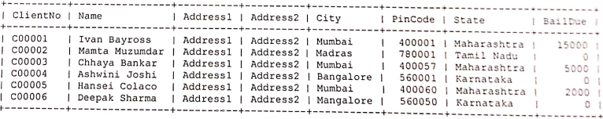

1. Data for Product_Master Table.

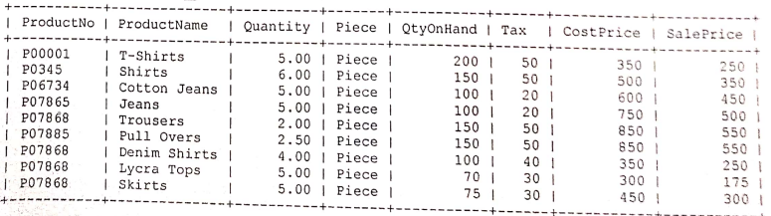

1. Data for Salesman_Master Table.

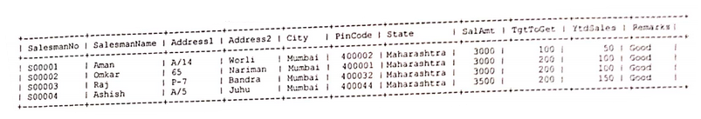

**Answer:**

1. **Command:**

INSERT INTO Client_Master

-> VALUES

-> ('C00001','Ivan Bayross','Address1','Address2','Mumbai',400001,'Maharashtra',15000),

-> ('C00002','Mamta Mazumdar','Address1','Address2','Madras',780001,'Tamil Nadu',0),

-> ('C00003','Chhaya Bankar','Address1','Address2','Mumbai',400057,'Maharashtra',5000),

-> ('C00004','Ashwini Joshi','Address1','Address2','Bangalore',560001,'Karnataka',0),

-> ('C00005','Hansei Colaco','Address1','Address2','Mumbai',400060,'Maharashtra',2000),

-> ('C00006','Deepak Sharma','Address1','Address2','Mangalore',560050,'Karnataka',0);

**Output:**

Query OK, 6 rows affected (0.02 sec)

Records: 6 Duplicates: 0 Warnings: 0

**Command:**

SELECT * FROM Client_Master;

**Output:**

+----------+----------------+----------+----------+-----------+---------+-------------+--------+

| ClientNo | Name | Address1 | Address2 | City | PinCode | Sate | BalDue |

+----------+----------------+----------+----------+-----------+---------+-------------+--------+

| C00001 | Ivan Bayross | Address1 | Address2 | Mumbai | 400001 | Maharashtra | 15000 |

| C00002 | Mamta Mazumdar | Address1 | Address2 | Madras | 780001 | Tamil Nadu | 0 |

| C00003 | Chhaya Bankar | Address1 | Address2 | Mumbai | 400057 | Maharashtra | 5000 |

| C00004 | Ashwini Joshi | Address1 | Address2 | Bangalore | 560001 | Karnataka | 0 |

| C00005 | Hansei Colaco | Address1 | Address2 | Mumbai | 400060 | Maharashtra | 2000 |

| C00006 | Deepak Sharma | Address1 | Address2 | Mangalore | 560050 | Karnataka | 0 |

+----------+----------------+----------+----------+-----------+---------+-------------+--------+

1. **Command:**

INSERT INTO Product_Master

-> VALUES

-> ('P0001', 'T-shirts', '5.00', 'Piece',200,50,350,250),

-> ('P0345', 'Shirts', '6.00', 'Piece',150,50,500,350),

-> ('P06734', 'Cotton Jeans', '5.00', 'Piece',100,20,600,450),

-> ('P07865', 'Jeans', '5.00', 'Piece',100,20,750,500),

-> ('P07868', 'Trousers', '2.00', 'Piece',150,50,850,550),

-> ('P07885','Pull Overs', '2.50', 'Piece', 150,50,850,550),

-> ('P07868', 'Denim Shirts', '4.00', 'Piece', 100,40,350,250),

-> ('P07868', 'Lycra Tops', '5.00', 'Piece', 70,30,300,175),

-> ('P07868', 'Skirts', '5.00', 'Piece', 75,30,450,300**);**

**Output:**

Query OK, 9 rows affected (0.01 sec)

**Command:**

SELECT * FROM Product_Master;

**Output:**

+-----------+--------------+----------+-------+-----------+------+-----------+-----------+

| ProductNo | ProductName | Quantity | Piece | QtyOnHand | Tax | CostPrice | SellPrice |

+-----------+--------------+----------+-------+-----------+------+-----------+-----------+

| P0001 | T-shirts | 5.00 | Piece | 200 | 50 | 350 | 250 |

| P0345 | Shirts | 6.00 | Piece | 150 | 50 | 500 | 350 |

| P06734 | Cotton Jeans | 5.00 | Piece | 100 | 20 | 600 | 450 |

| P07865 | Jeans | 5.00 | Piece | 100 | 20 | 750 | 500 |

| P07868 | Trousers | 2.00 | Piece | 150 | 50 | 850 | 550 |

| P07885 | Pull Overs | 2.50 | Piece | 150 | 50 | 850 | 550 |

| P07868 | Denim Shirts | 4.00 | Piece | 100 | 40 | 350 | 250 |

| P07868 | Lycra Tops | 5.00 | Piece | 70 | 30 | 300 | 175 |

| P07868 | Skirts | 5.00 | Piece | 75 | 30 | 450 | 300 |

+-----------+--------------+----------+-------+-----------+------+-----------+-----------+

1. **Command:**

INSERT INTO Salesman_Master

-> VALUES

-> ('S00001', 'Aman', 'A/14', 'Worli', 'Mumbai', '400002', 'Maharashtra', 3000,100,50,'Good'),

-> ('S00002', 'Omkar', '65', 'Nariman', 'Mumbai', '400001', 'Maharashtra', 3000,200,100,'Good'),

-> ('S00003', 'Raj', 'P-7', 'Bandra', 'Mumbai', '400032', 'Maharashtra', 3000,200,100,'Good'),

-> ('S00004', 'Ashish', 'A/7', 'Juhu', 'Mumbai', '400044', 'Maharashtra', 3500,200,150,'Good');

**Output:**

Query OK, 4 rows affected (0.01 sec)

Records: 4 Duplicates: 0 Warnings: 0

**Command:**

SELECT * FROM Salesman_Master;

**Output:**

+------------+--------------+----------+----------+--------+---------+-------------+--------+----------+----------+---------+

| SalesmanNo | SalesmanName | Address1 | Address2 | City | PinCode | State | SalAmt | TgttoGet | YtdSales | Remarks |

+------------+--------------+----------+----------+--------+---------+-------------+--------+----------+----------+---------+

| S00001 | Aman | A/14 | Worli | Mumbai | 400002 | Maharashtra | 3000 | 100 | 50 | Good |

| S00002 | Omkar | 65 | Nariman | Mumbai | 400001 | Maharashtra | 3000 | 200 | 100 | Good |

| S00003 | Raj | P-7 | Bandra | Mumbai | 400032 | Maharashtra | 3000 | 200 | 100 | Good |

| S00004 | Ashish | A/7 | Juhu | Mumbai | 400044 | Maharashtra | 3500 | 200 | 150 | Good |

+------------+--------------+----------+----------+--------+---------+-------------+--------+----------+----------+---------+

**Exercise 3:** Exercise on retrieving the data.

1. Find out the name of all the clients.
2. Retrieve the entire contents of the Client_Master table.
3. Retrieve the list of names, city and the state of all the clients.
4. List the various products available from the Product_Master table.
5. List all the clients who live in Mumbai.
6. Find the names of salesman who have a salary equal to Rs. 3000.

**Answer:**

1. **Command:**

SELECT Name FROM Client_Master;

**Output:**

+----------------+

| Name |

+----------------+

| Ivan Bayross |

| Mamta Mazumdar |

| Chhaya Bankar |

| Ashwini Joshi |

| Hansei Colaco |

| Deepak Sharma |

+----------------+

1. **Command:**

SELECT * FROM Client_Master;

**Output:**

+----------+----------------+----------+----------+-----------+---------+-------------+--------+

| ClientNo | Name | Address1 | Address2 | City | PinCode | Sate | BalDue |

+----------+----------------+----------+----------+-----------+---------+-------------+--------+

| C00001 | Ivan Bayross | Address1 | Address2 | Mumbai | 400001 | Maharashtra | 15000 |

| C00002 | Mamta Mazumdar | Address1 | Address2 | Madras | 780001 | Tamil Nadu | 0 |

| C00003 | Chhaya Bankar | Address1 | Address2 | Mumbai | 400057 | Maharashtra | 5000 |

| C00004 | Ashwini Joshi | Address1 | Address2 | Bangalore | 560001 | Karnataka | 0 |

| C00005 | Hansei Colaco | Address1 | Address2 | Mumbai | 400060 | Maharashtra | 2000 |

| C00006 | Deepak Sharma | Address1 | Address2 | Mangalore | 560050 | Karnataka | 0 |

+----------+----------------+----------+----------+-----------+---------+-------------+--------+

1. **Command:**

SELECT Name, City, State FROM Client_Master;

**Output:**

+----------------+-----------+-------------+

| Name | City | Sate |

+----------------+-----------+-------------+

| Ivan Bayross | Mumbai | Maharashtra |

| Mamta Mazumdar | Madras | Tamil Nadu |

| Chhaya Bankar | Mumbai | Maharashtra |

| Ashwini Joshi | Bangalore | Karnataka |

| Hansei Colaco | Mumbai | Maharashtra |

| Deepak Sharma | Mangalore | Karnataka |

+----------------+-----------+-------------+

1. **Command:**

SELECT ProductName FROM Product_Master;

**Output:**

+--------------+

| ProductName |

+--------------+

| T-shirts |

| Shirts |

| Cotton Jeans |

| Jeans |

| Trousers |

| Pull Overs |

| Denim Shirts |

| Lycra Tops |

| Skirts |

+--------------+

1. **Command:**

SELECT Name FROM Client_Master

-> WHERE City = 'Mumbai';

**Output:**

+---------------+

| Name |

+---------------+

| Ivan Bayross |

| Chhaya Bankar |

| Hansei Colaco |

+---------------+

1. **Command:**

SELECT SalesmanName FROM Salesman_Master

-> WHERE SalAmt = 3000;

**Output:**

+--------------+

| SalesmanName |

+--------------+

| Aman |

| Omkar |

| Raj |

+--------------+

**Exercise 4:** Exercise on the updating the records in the table.

1. Change the city of ClientNo ‘C00005’ to Banglore.
2. Change the BalDue of ClientNo ‘C00001’ to Rs 1000.
3. Change the cost price of ‘Trousers’ to Rs. 950.00.
4. Change the city of the salesman to Pune.

**Answer:**

1. **Command:**

UPDATE Client_Master SET City = 'Bangalore'

-> WHERE ClientNo = 'C00005';

**Output:**

Query OK, 1 row affected (0.01 sec)

Rows matched: 1 Changed: 1 Warnings: 0

**Command:**

SELECT * FROM Client_Master;

**Output:**

+----------+----------------+----------+----------+-----------+---------+-------------+--------+

| ClientNo | Name | Address1 | Address2 | City | PinCode | State | BalDue |

+----------+----------------+----------+----------+-----------+---------+-------------+--------+

| C00001 | Ivan Bayross | Address1 | Address2 | Mumbai | 400001 | Maharashtra | 15000 |

| C00002 | Mamta Mazumdar | Address1 | Address2 | Madras | 780001 | Tamil Nadu | 0 |

| C00003 | Chhaya Bankar | Address1 | Address2 | Mumbai | 400057 | Maharashtra | 5000 |

| C00004 | Ashwini Joshi | Address1 | Address2 | Bangalore | 560001 | Karnataka | 0 |

| C00005 | Hansei Colaco | Address1 | Address2 | Bangalore | 400060 | Maharashtra | 2000 |

| C00006 | Deepak Sharma | Address1 | Address2 | Mangalore | 560050 | Karnataka | 0 |

+----------+----------------+----------+----------+-----------+---------+-------------+--------+

1. **Command:**

UPDATE Client_Master SET BalDue = 1000

-> WHERE ClientNo = 'C00001';

**Output:**

Query OK, 1 row affected (0.01 sec)

Rows matched: 1 Changed: 1 Warnings: 0

**Command:**

SELECT * FROM Client_Master;

**Output:**

+----------+----------------+----------+----------+-----------+---------+-------------+--------+

| ClientNo | Name | Address1 | Address2 | City | PinCode | State | BalDue |

+----------+----------------+----------+----------+-----------+---------+-------------+--------+

| C00001 | Ivan Bayross | Address1 | Address2 | Mumbai | 400001 | Maharashtra | 1000 |

| C00002 | Mamta Mazumdar | Address1 | Address2 | Madras | 780001 | Tamil Nadu | 0 |

| C00003 | Chhaya Bankar | Address1 | Address2 | Mumbai | 400057 | Maharashtra | 5000 |

| C00004 | Ashwini Joshi | Address1 | Address2 | Bangalore | 560001 | Karnataka | 0 |

| C00005 | Hansei Colaco | Address1 | Address2 | Bangalore | 400060 | Maharashtra | 2000 |

| C00006 | Deepak Sharma | Address1 | Address2 | Mangalore | 560050 | Karnataka | 0 |

+----------+----------------+----------+----------+-----------+---------+-------------+--------+

1. **Command:**

UPDATE Product_Master SET CostPrice = 950

-> WHERE ProductName = 'Trousers';

**Output:**

Query OK, 1 row affected (0.01 sec)

Rows matched: 1 Changed: 1 Warnings: 0

**Command:**

SELECT * FROM Product_Master;

**Output:**

+-----------+--------------+----------+-------+-----------+------+-----------+-----------+

| ProductNo | ProductName | Quantity | Piece | QtyOnHand | Tax | CostPrice | SellPrice |

+-----------+--------------+----------+-------+-----------+------+-----------+-----------+

| P0001 | T-shirts | 5.00 | Piece | 200 | 50 | 350 | 250 |

| P0345 | Shirts | 6.00 | Piece | 150 | 50 | 500 | 350 |

| P06734 | Cotton Jeans | 5.00 | Piece | 100 | 20 | 600 | 450 |

| P07865 | Jeans | 5.00 | Piece | 100 | 20 | 750 | 500 |

| P07868 | Trousers | 2.00 | Piece | 150 | 50 | 950 | 550 |

| P07885 | Pull Overs | 2.50 | Piece | 150 | 50 | 850 | 550 |

| P07868 | Denim Shirts | 4.00 | Piece | 100 | 40 | 350 | 250 |

| P07868 | Lycra Tops | 5.00 | Piece | 70 | 30 | 300 | 175 |

| P07868 | Skirts | 5.00 | Piece | 75 | 30 | 450 | 300 |

+-----------+--------------+----------+-------+-----------+------+-----------+-----------+

1. **Command:**

UPDATE Salesman_Master SET City = 'Pune';

**Output:**

Query OK, 4 rows affected (0.01 sec)

Rows matched: 4 Changed: 4 Warnings: 0

**Command:**

SELECT * FROM Salesman_Master;

**Output:**

+------------+--------------+----------+----------+--------+---------+-------------+--------+----------+----------+---------+

| SalesmanNo | SalesmanName | Address1 | Address2 | City | PinCode | State | SalAmt | TgttoGet | YtdSales | Remarks |

+------------+--------------+----------+----------+--------+---------+-------------+--------+----------+----------+---------+

| S00001 | Aman | A/14 | Worli | Mumbai | 400002 | Maharashtra | 3000 | 100 | 50 | Good |

| S00002 | Omkar | 65 | Nariman | Mumbai | 400001 | Maharashtra | 3000 | 200 | 100 | Good |

| S00003 | Raj | P-7 | Bandra | Mumbai | 400032 | Maharashtra | 3000 | 200 | 100 | Good |

| S00004 | Ashish | A/7 | Juhu | Mumbai | 400044 | Maharashtra | 3500 | 200 | 150 | Good |

+------------+--------------+----------+----------+--------+---------+-------------+--------+----------+----------+---------+